MINI PROJECT REPORT
(2019-20)

SMART IRRIGATION SYSTEM



Institute of Engineering & Technology

Team Members
Himanshu Sharma
(171500137)
Abhay Singh
(171500003)

Supervised By
Neeraj Khanna
Asst. Professor
Department of Computer Engineering & Applications

CERTIFICATE

This is to certify that Project Report entitled “Smart Irrigation System” which is submitted by Abhay Singh and Himanshu Sharma , in partial fulfillment of the requirement for the award of degree B.Tech in Department of Computer Science and Engineering of GLA University, is a record of the candidate own work carried out by him under my supervision. The matter embodied in this thesis is original and has not been submitted for the award of any other degree.

Date: Supervisor:

DECLARATION

I hereby declare that the Project Report entitled “Smart Irrigation System” submitted by me to GLA University, in partial fulfillment of the requirement for the award of the degree of B.Tech in Computer Science Department is a record of bonafide project work carried out by me under the guidance of Mr. Neeraj Khanna. This submission is my own work and that, to the best of my knowledge and belief , it contains no material previously published or written by another person and not be submitted, either in part or in full, for the award of any other degree or diploma in this university or any other.

Date: Signature of Student

ACKNOWLEDGEMENT

It gives us a great sense of pleasure to present the report of the B.Tech Mini Project undertaken during B.Tech Third year.

We owe special debt of gratitude to our Supervisior Mr. Neeraj Khanna , Department of Computer Science and Engineering, GLA University, Mathura for his constant support and guidance throughout the course of work. His sincerity, thoroughness and perseverance have been a constant source of inspiration for us. It is only his cognizant efforts that our endeavors have seen light of the day.

Special thanks to all the faculties for encouraging me constantly to work hard in this project. I pay my respect and love to my parents and all others family members and friends for their help and encouragement throughout this course of project work.

ABSTRACT

Agriculture remains the sector which contributes the highest to India’s GDP. But, when considering technology that is deployed in this field, we find that the development is not tremendous. Irrigation is one method to supply water but in some cases there will be lot of water wastage. So in this regard to save water and time we have proposed project titled Smart Irrigation System under the use of technology IOT. In this proposed system we are using various sensors like humidity, soil moisture sensors which senses the various parameters of the soil based on soil moisture value land gets automatically irrigated by ON/OFF of the motor.
These sensed parameters and motor status will be displayed on Blynk application.

TABLE OF CONTENTS

1. Certificate
2.Declaration
3.Acknowledgement
4.Abstract
5.Introduction
I. General Introduction to the topic
II.Applications
III.Area of Computer Science
IV. Hardware and Software Requirements
6.Problem Definition
7.Objective
8.Methodology
9.Implementations Details
I. Description of Hardware Components
II. Circuit Diagram
III. Implementations steps
10.Conclusion and Future Scope
I. Conclusion
II. Future Scope
11.Bibliography

INTRODUCTION

The Smart Irrigation System is an IOT based device which is capable of automating the irrigation process by analyzing the moisture of soil. The smart Irrigation System has wide scope to automate the complete irrigation system. Here we are building a IOT based irrigation system using different tools.

Most of the farmers use large portions of farming land and it becomes very difficult to reach and track each corners of large lands. Sometime there is a possibility of uneven water sprinkles. This result in the bad quality crops which further leads to financial losses. In this scenario the Smart Irrigation System using IoT technology is helpful and leads to ease of farming.

IoT is changing the agriculture domain and empowering farmers to fight with the huge difficulties they face. The agriculture must overcome expanding water deficiencies, restricted availability of lands, while meeting the expanding consumption needs of a world population. New innovative IoT applications are addressing these issues and increasing the quality, quantity, sustainability and cost effectiveness of agricultural production.

Agriculture is the backbone of Indian Economy. In today’s world, as we see rapid growth in global population, agriculture becomes more important to meet the needs of the human race. However, agriculture requires irrigation and with every year we have more water consumption than rainfall, it becomes critical for growers to find ways to conserve water while still achieving the highest yield. But in the present era, the farmers have been using irrigation technique through the manual control in which they irrigate the land at the regular interval.

APPLICATIONS

- It can be used in agricultural fields, lawns and as drip irrigation system
- It can be used for cultivation purpose
- It can be used to provide water in nursery planting arena
- It can be used for wide range of crops as one can customize reference required for different kind of crops
- Pond water management and water transfer

ADVANTAGES

- Water conservation :
Soil moisture sensor allow for water use only when and where needed

- Real time data give:
Farmers can visualize water levels and soil moisture in real time and remotely to accelerate decision making process

- Lowered operation cost
- Efficient and saves time
- Increase in productivity
- Reduce soil erosion and nutrient leaching

HARDWARE AND SOFTWARE REQUIREMENTS

Hardware Requirements:-

- Node MCU
- Soil moisture sensor
- Jumper wires
- Bread board
- DC Motor
- Pipe
- Plant

Software Requirements:-
- Arduino IDE
- Blynk Application

PROBLEM STATEMENT

In the case of traditional irrigation system water saving is not considered. Since, the water is irrigated directly in the land, plants under go high stress from variation in soil moisture, therefore plant appearance is reduced. The absence of automatic controlling of the system result in improper water control system. The major reason for these limitations is the growth of population which is increasing at a faster rate. At present there is emerging global water crisis where managing scarcity of water has become a serious job. This growth can be seen in countries which have shortage of water resources and are economically poor. So this is the serious problem in agriculture area. So we want to design an Smart Irrigation System to help the society.

OBJECTIVE

Water is one of the essential elements of human existence. It is not always to get water supply from natural sources. Here comes the model of irrigation system. Irrigation is the man-made means of supplying water. The main objectives of irrigation supply are given below-
.
- Ensure enough moisture essential for plant growth.
- Cool the soil and atmosphere to provide a suitable surrounding
- To develop a smart irrigation system in order to get a significant saving in the consumption of water to irrigate the crops and to provide sufficient flow capacity to meet the irrigation demand
METHODOLOGY

The outmoded irrigation technique has been replaced with automated technique. Many smart irrigation systems have been devised. A smart irrigation system, contrary to a traditional irrigation method, regulates supplied water according to the needs of the fields and crops. The feedback mechanism of a smart irrigation system is a moisture sensor. This moisture sensor is placed at a specific location on the irrigation field. Based on its value the water is being pumped to corresponding area up to a predetermined time.

The smart irrigation system has wide scope to automate the complete irrigation system. Here we are building a IoT based irrigation System using ESP8266 NodeMCU Module and soil moisture Sensor. It will not only automatically irrigates the water based on the moisture level in the soil but also send the data to Blynk app to keep track of land condition. The system will consist a water pump which will used to sprinkle water on the land depending upon the land environmental condition such as moisture and humidity.

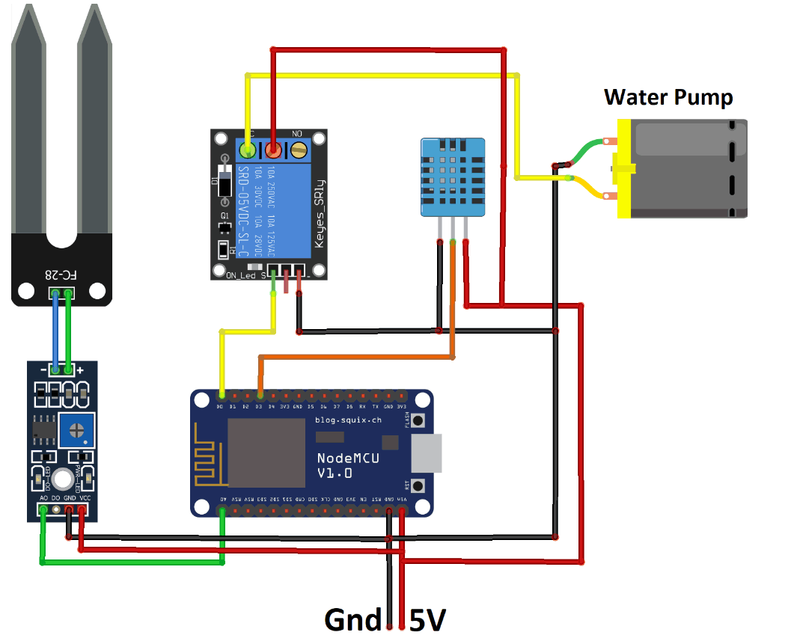

IMPLEMENTATION DETAILS

Description of Hardware Components

NODE MCU:-

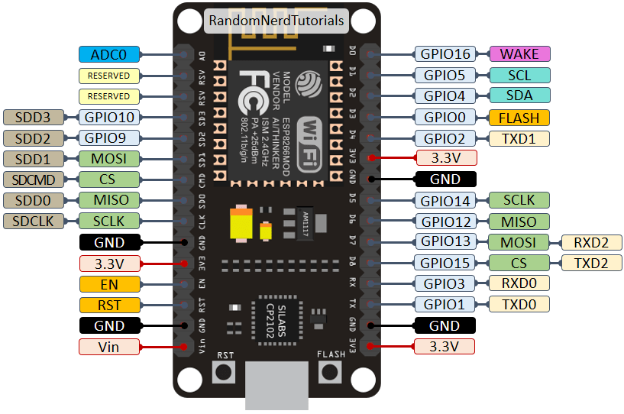

NODE MCU is an open source IoT platform.It includes firmware which runs on the ESP 8266 WIFI SoC and hardware which is based on the ESP 12 module. It is a low cost Wi-Fi module chip that can be configured to connect to the internet for Internet of Things.

ARDUINO is an open source physical computing platform
based on a simple microcontroller board and a development
environment for writing software for the board. It has 14
digital pins, 6 analog pins, 16 MHZ crystal oscillator, a USB
connection, a power source jack and a reset button.
RDUINO is an open source physical computing platform
based on a simple microcontroller board and a development
environment for writing software for the board. It has 14
digital pins, 6 analog pins, 16 MHZ crystal oscillator, a USB
connection, a power source jack and a reset button.
ARDUINO is an open source physical computing platform
based on a simple microcontroller board and a development
environment for writing software for the board. It has 14
digital pins, 6 analog pins, 16 MHZ crystal oscillator, a USB
connection, a power source jack and a reset button.
ARDUINO is an open source physical computing platform
based on a simple microcontroller board and a development
environment for writing software for the board. It has 14
digital pins, 6 analog pins, 16 MHZ crystal oscillator, a USB
connection, a power source jack and a reset button.
ARDUINO is an open source physical computing platform
based on a simple microcontroller board and a development
environment for writing software for the board. It has 14
digital pins, 6 analog pins, 16 MHZ crystal oscillator, a USB
connection, a power source jack and a reset button.
ARDUINO is an open source physical computing platform
based on a simple microcontroller board and a development
environment for writing software for the board. It has 14
digital pins, 6 analog pins, 16 MHZ crystal oscillator, a USB
connection, a power source jack and a reset button.
ARDUINO is an open source physical computing platform
based on a simple microcontroller board and a development
environment for writing software for the board. It has 14
digital pins, 6 analog pins, 16 MHZ crystal oscillator, a USB
connection, a power source jack and a reset button.
ARDUINO is an open source physical computing platform
based on a simple microcontroller board and a development
environment for writing software for the board. It has 14
digital pins, 6 analog pins, 16 MHZ crystal oscillator, a USB
connection, a power source jack and a reset button.
ARDUINO is an open source physical computing platform
based on a simple microcontroller board and a development
environment for writing software for the board. It has 14
digital pins, 6 analog pins, 16 MHZ crystal oscillator, a USB
connection, a power source jack and a reset button.
ARDUINO is an open source physical computing platform
based on a simple microcontroller board and a development
environment for writing software for the board. It has 14
digital pins, 6 analog pins, 16 MHZ crystal oscillator, a USB
connection, a power source jack and a reset button.
ARDUINO is an open source physical computing platform
based on a simple microcontroller board and a development
environment for writing software for the board. It has 14
digital pins, 6 analog pins, 16 MHZ crystal oscillator, a USB
connection, a power source jack and a reset button.
ARDUINO is an open source physical computing platform
based on a simple microcontroller board and a development
environment for writing software for the board. It has 14
digital pins, 6 analog pins, 16 MHZ crystal oscillator, a USB
connection, a power source jack and a reset button.
ARDUINO is an open source physical computing platform
based on a simple microcontroller board and a development
environment for writing software for the board. It has 14
digital pins, 6 analog pins, 16 MHZ crystal oscillator, a USB
connection, a power source jack and a reset button.
ARDUINO is an open source physical computing platform
based on a simple microcontroller board and a development
environment for writing software for the board. It has 14
digital pins, 6 analog pins, 16 MHZ crystal oscillator, a USB
connection, a power source jack and a reset button.
ARDUINO is an open source physical computing platform
based on a simple microcontroller board and a development
environment for writing software for the board. It has 14
digital pins, 6 analog pins, 16 MHZ crystal oscillator, a USB
connection, a power source jack and a reset button.
ARDUINO is an open source physical computing platform
based on a simple microcontroller board and a development
environment for writing software for the board. It has 14
digital pins, 6 analog pins, 16 MHZ crystal oscillator, a USB
connection, a power source jack and a reset button.

ARDUINO is an open source physical computing platform
based on a simple microcontroller board and a development
environment for writing software for the board. It has 14
digital pins, 6 analog pins, 16 MHZ crystal oscillator, a USB
connection, a power source jack and a reset button

ARDUINO is an open source physical computing platform
based on a simple microcontroller board and a development
environment for writing software for the board. It has 14
digital pins, 6 analog pins, 16 MHZ crystal oscillator, a USB
connection, a power source jack and a reset button

ARDUINO is an open source physical computing platform
based on a simple microcontroller board and a development
environment for writing software for the board. It has 14
digital pins, 6 analog pins, 16 MHZ crystal oscillator, a USB
connection, a power source jack and a reset button

ARDUINO is an open source physical computing platform
based on a simple microcontroller board and a development
environment for writing software for the board. It has 14
digital pins, 6 analog pins, 16 MHZ crystal oscillator, a USB
connection, a power source jack and a reset button

ARDUINO is an open source physical computing platform
based on a simple microcontroller board and a development
environment for writing software for the board. It has 14
digital pins, 6 analog pins, 16 MHZ crystal oscillator, a USB
connection, a power source jack and a reset button

ARDUINO is an open source physical computing platform
based on a simple microcontroller board and a development
environment for writing software for the board. It has 14
digital pins, 6 analog pins, 16 MHZ crystal oscillator, a USB
connection, a power source jack and a reset button

ARDUINO is an open source physical computing platform
based on a simple microcontroller board and a development
environment for writing software for the board. It has 14
digital pins, 6 analog pins, 16 MHZ crystal oscillator, a USB
connection, a power source jack and a reset butto

SOIL MOISTURE SENSOR :-
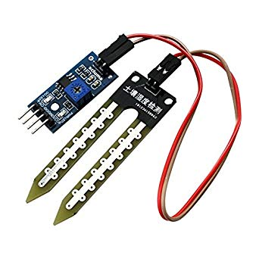
The soil moisture sensor is used to measure the volumetric water content of soil. It is used to monitor soil moisture content to control irrigation. A moisture sensor is used to sense the level of moisture content present in
irrigation field. It has a level detection module in which we can set a reference value.

DC MOTOR PUMP :-

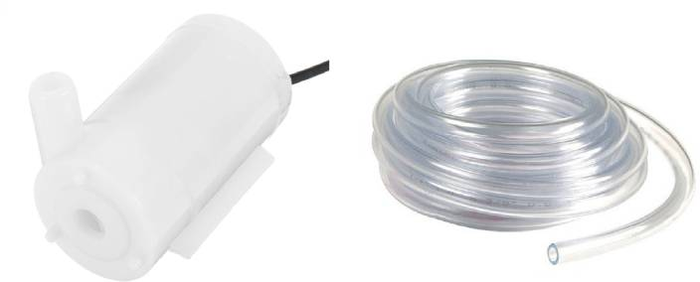

DC powered pumps use direct current from motor, battery, or solar power to move fluid in a variety of ways. Motorized pumps typically operate on 6, 12, 24, or 32 volts of DC power.

RELAY:-

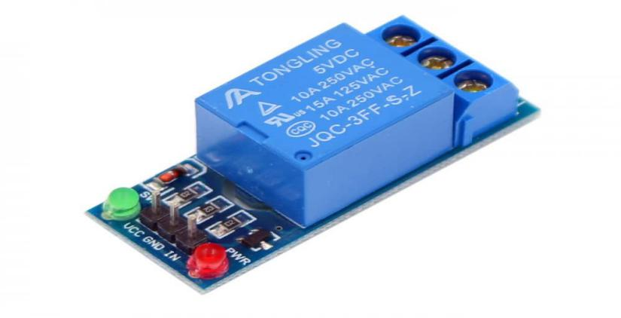

A relay is an electrically operated switch . It consists of a set of input terminals for a single or multiple control signals and a set of operating contact terminals. The switch may have any number of contacts in multiple contact forms.

BREADBOARD:-

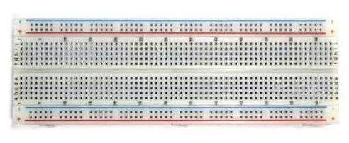

A breadboard is a solder-less device for temporary prototype with electronics and test circuit designs. Most electronic components in electronic circuits can be interconnected by inserting their leads or terminals into the holes and then making connections through wires where appropriate.

JUMPER WIRES :-

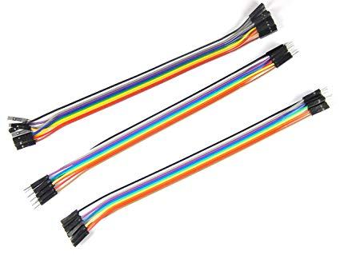

Jumper Wires are simply wires that have connector pins at each end, allowing them to be used to connect two points to each other without soldering. Jumper wires are typically used with breadboards and other prototyping tools in order to make it easy to change a circuit as needed.

The implementing steps are:-

The smart irrigation system has wide scope to automate the complete irrigation system. Here we are building a IoT based irrigation System using ESP8266 NodeMCU Module and soil moisture Sensor. It will not only automatically irrigates the water based on the moisture level in the soil but also send the data to Blynk app to keep track of land condition. The system will consist a water pump which will used to sprinkle water on the land depending upon the land environmental condition such as moisture and humidity.

Step:-1 Firstly we will connect the Node MCU ESP8266 with the breadboard

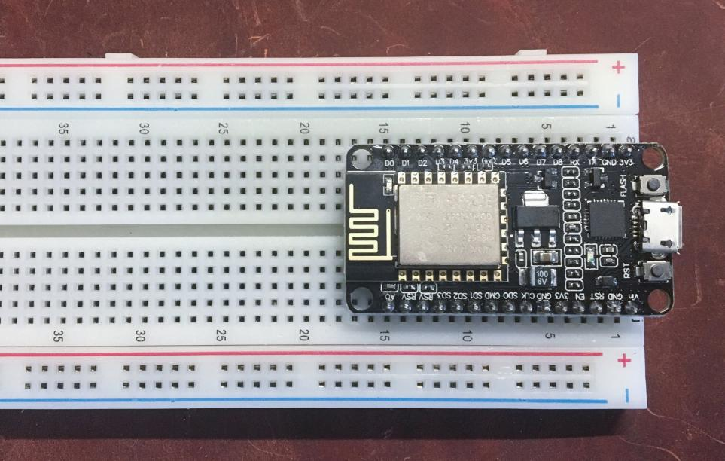

Step 2: Connecting the soil moisture sensor with the NodeMCU ESP8266. The pin connections are:-

VCC pin of sensor with Node MCU VCC pin
Ao pin of sensor with Node MCU Ao pin
GND pin of sensor with Node MCU GND pin
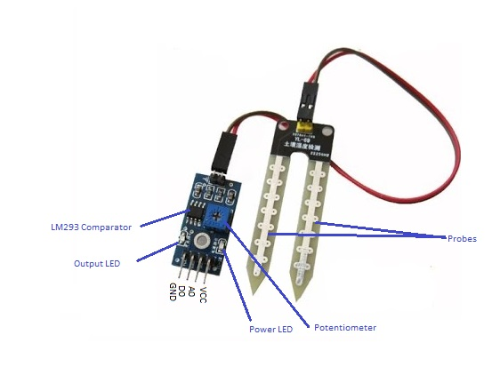
Soil Moisture Sensor

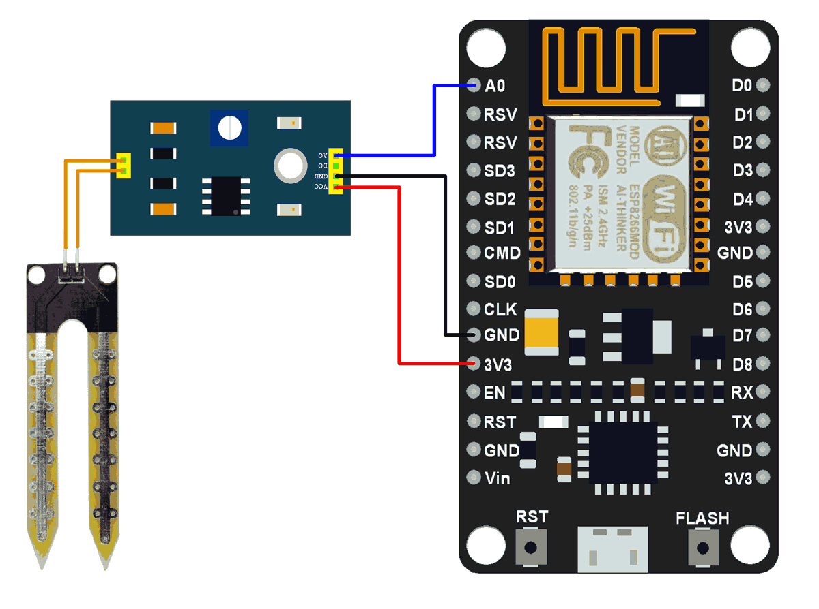

Moisture Sensor with Node MCU ESP8266

Step 3:- Connecting the relay module with NodeMCU. The pin connections will be:-
GND pin - GND pin
D0 pin with any data pin of Node MCU
VCC pin with 3V3

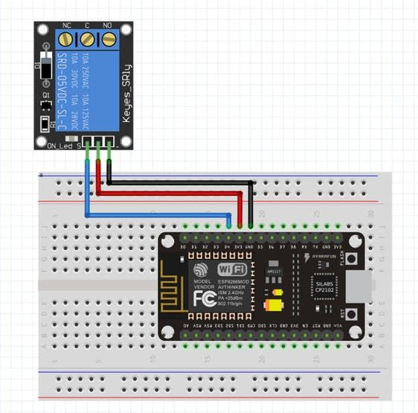

Step 4:- Here we are using 9V dc water pump, so we connect it with 9V battery for better performance.

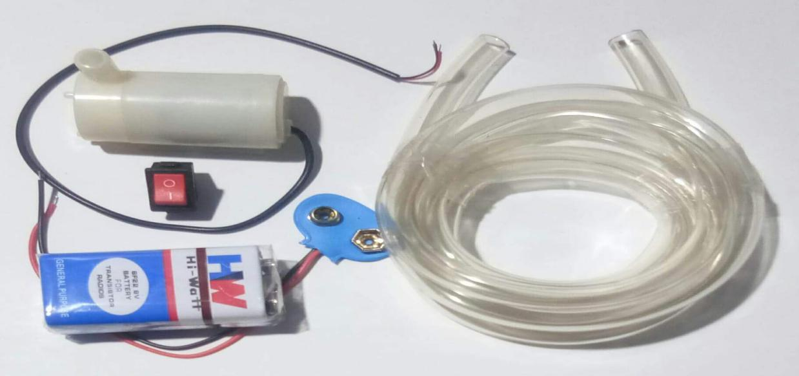

Step:-5 . Now we connect the water pump with relay module and with battery.
After all these steps, the entire hardware connections is prepared.

Software / Coding Part

Step 6:- Download the arduino Ide in your system and blynk application in your mobile.
In arduino ide we will upload and the program of the project and in Blynk app we will set up the moisture level gauge in which the moisture percentage present in soil will shown up.

Step 7:- We will connect the blynk with Node MCU through Wi-Fi module

char auth[] = "adpTxH70i5pdh86QbhXESeRO9T1Yrn9y"; // token id
char ssid[] = "WIFI NAME ";
char pass[] = "PASSWORD";

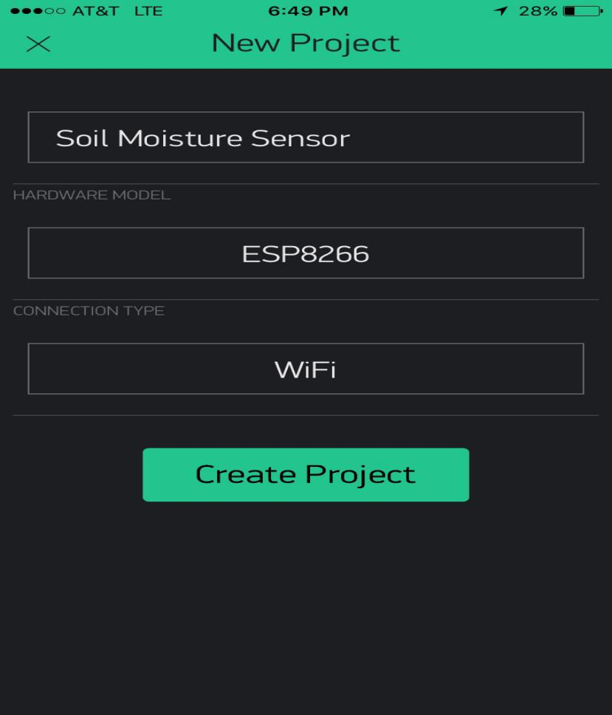

Step 8:- The water pump will automatically on/off with respect to moisture percentage present in soil which will be given by soil moisture sensor. If the moisture percent is low, then the motor will be on and the soil receives water until the moisture percent will reach the threshold value ,motor will be off.

BlynkTimer timer;

void pump()
{
int value = analogRead(sensorpin);
int value1=map(value,550,0,0,100);
Blynk.virtualWrite(V1,value1);
if (value1<20)
{
digitalWrite(moterpin, LOW);
}
else
{
digitalWrite(moterpin ,HIGH);
}
}

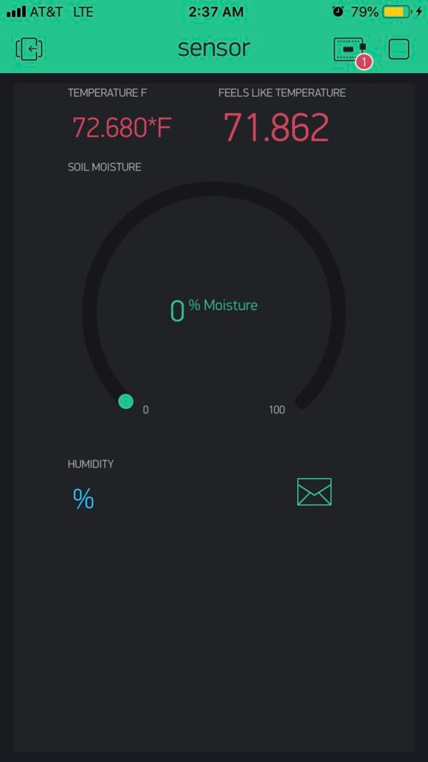

Step 9:- We will connect the Node MCU ESP8266 with Arduino ide with cable. Upload the program in ide . After uploading the program the model will on. Below there is the code of our project. The model will start functioning

CODE

#define BLYNK_PRINT Serial
#include <ESP8266WiFi.h>
#include <BlynkSimpleEsp8266.h>

#define moterpin D7
#define sensorpin A0

int value1=0;
char auth[] = "XOIX3iZr5-eT7vRUuuztB80m7OQJxMFm";
char ssid[] = "AndroidAP";
char pass[] = "himanshu";

BlynkTimer timer;

void pump()
{
int value = analogRead(sensorpin);
int value1=map(value,550,0,0,100);
Blynk.virtualWrite(V1,value1);
if (value1<20)
{
digitalWrite(moterpin, LOW);
}
else
{
digitalWrite(moterpin ,HIGH);
}
}
void setup()
{

Serial.begin(9600);
Blynk.begin(auth, ssid, pass);
pinMode(moterpin,OUTPUT);
digitalWrite(moterpin,LOW);
pinMode(sensorpin,INPUT);
timer.setInterval(1000L, pump);

}

void loop()
{
Blynk.run();
timer.run();

}

Step 10:- When the code will be uploaded in arduino ide, the system will operate. Soil moisture sensor reading will show in blynk and according to the moisture percentage, the motor will be on/off.

CONCLUSION

- The objective of this project is to avoid wastage of water and increase irrigation efficiency by using a NodeMCU based irrigation system with the help of moisture sensor.
- Smart Irrigation System control technology is easily deployable and can be controlled manually or automatically without physical presence at the system or field.
- The smart irrigation system is feasible and cost effective for optimizing water resources for agricultural productions
- It proves that the use of water can be diminished

FUTURE SCOPE

The project has tremendous scope in developing it and making it more user-friendly and with additional features like :-
- To capture the photos and webcam can be installed to the device, which can be sent to the database
- Implementation of speech based option for those who are unable to read
- A device with a GPS can be integrated to provide specific location of the farmer and more accurate weather reports of agriculture field and garden
- All the features on device end can be developed in the regional language, which helps in easy reading for the farmers

BIBLIOGRAPHY

References:-

Circuitdigest.com
Electronicsforu.com
Instructables.com

